Social Justice at Nativity
Nativity’s Social Justice Committee shares the following announcements, events and recommended resources to the Nativity community as we continue our pursuit of racial justice and reconciliation.
Announcements & Events
Pilgrimage Survey Results and Update
The Nativity Pilgrimage Team would like to thank all of you who participated in our recent survey. As a result of your feedback, we will be focusing on short (one to two day) pilgrimage experiences in our area, to begin in the spring or early fall of 2023. The Episcopal Diocese of North Carolina is also organizing day pilgrimages in NC. We will keep you posted as both our and the Diocese’s plans develop and are scheduled. If you have questions or comments about Nativity’s involvement in social justice themed pilgrimages, please contact Beth Crow at mary.crow@me.com or 919-208-0438.

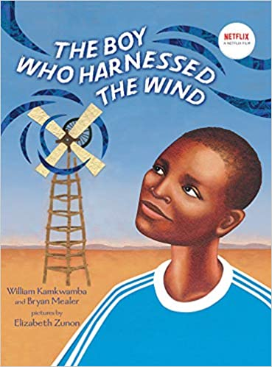
Peace Library - Monthly Book Review
Review of: The Boy Who Harnessed the Wind (Young Reader's Edition)
Reviewer: Becky Showalter
Click here to read full review.

How to Talk with Kids about Racism & Diversity
Sunday, November 6th, 9:30 am
Nativity’s Education Building, second room on the right
Nativity’s Peace Library Team will host a beginning discussion on “How to Talk with Kids about Racism and Diversity.” During this time, we will share resources and activities that can help facilitate a valuable discussion with your children, as well as review some of the many books available in our Peace Library.

All the Way
October 14-15, October 21-23
The Justice Theater Project
Umstead Park United Church of Christ, 8208 Brownleigh Drive, Raleigh
Tickets: Click here. Cost: $5 and up
All the Way documents LBJ's relationship with Martin Luther King and his influential political peers. It offers an intricate and intimate portrayal of how LBJ bent Congress to his own will. He made his own stamp on presidential history. Adult language.

National Day of Action March – Raleigh, NC
NC Poor People's Campaign, Saturday, October 15, 12pm
Location: TBA
Cost is free. Click here to register and for more information.
Join with Poor People's Campaign leaders across the country to declare that
the issues of poor and low-income people and low wage workers should be at
the center of the national narrative around the election. Help organize and
mobilize poor and low-income voters to the polls.
Hip Hop Caucus: Get Out the Vote Concert
Saturday, October 22, 2022 at 7 pm
Transfer Company Food Hall, 500 East Davie Street, Raleigh
Cost is free. Click here to register and for more information.
Black Farmers Market
Sunday, October 23, 2022, 1:00-4:00 pm
Southeast Raleigh YMCA (1436 Rock Quarry Rd)
Community Class Series: The Wilmington Coup of 1898
Wednesday, November 2, 2022 at 7 pm – In Person
North Carolina Museum of History
Cost is free. Click here to register and for more information.
Recommended Resources
Racial Justice and Reconciliation (Episcopal Diocese of North Carolina) - Website
This website (click here) is updated regularly with social justice programs recommended by the diocese’s Racial Justice and Reconciliation Committee.

